Connection string

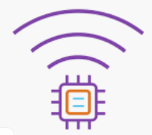

What we need?

We need to collect information about IoT Hub and device to connect to it

* IoT Hub:
  + Name,
  + Primary key,
  + connection string
* Device :
  + ID,
  + Primary key,
  + connection string

Get IoT Hub Connection String

Open Azure portal, Resource group, Resort name

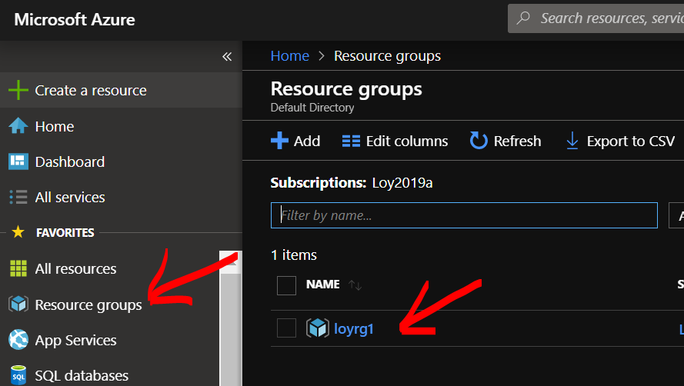

Click IoT Hub name

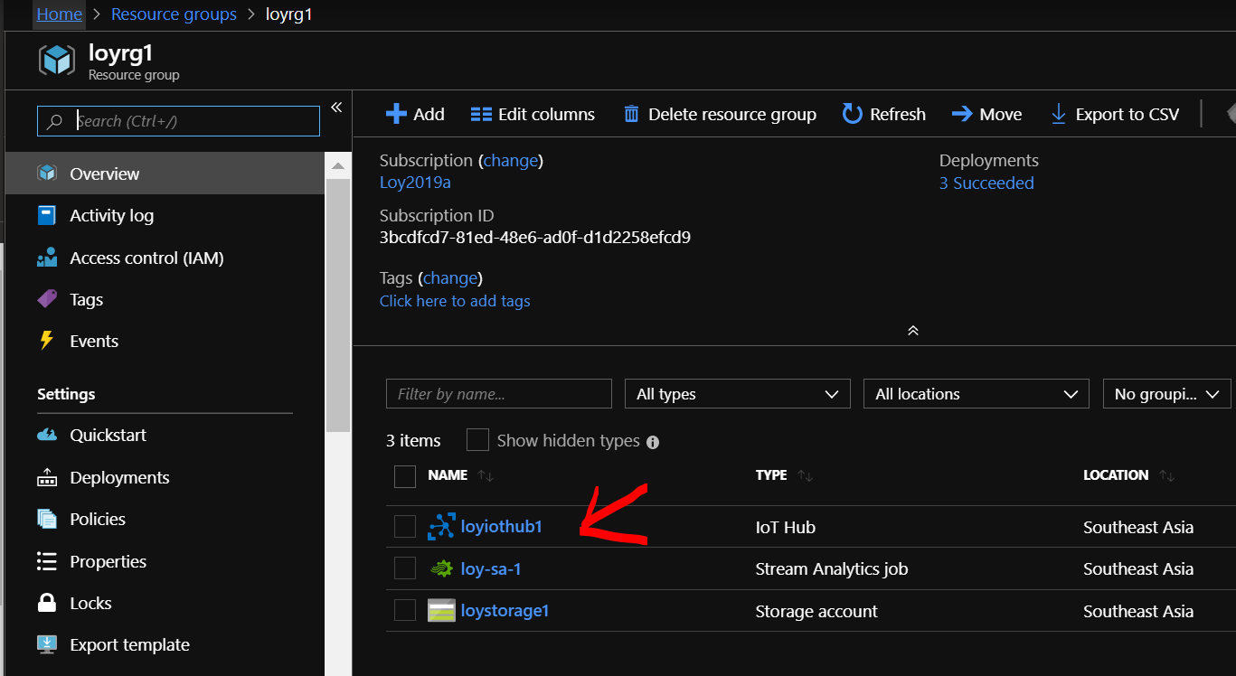

Click Shared access policies / Service

Copy IoT Hub Name, Primary key and Connection string / pates into Notepad

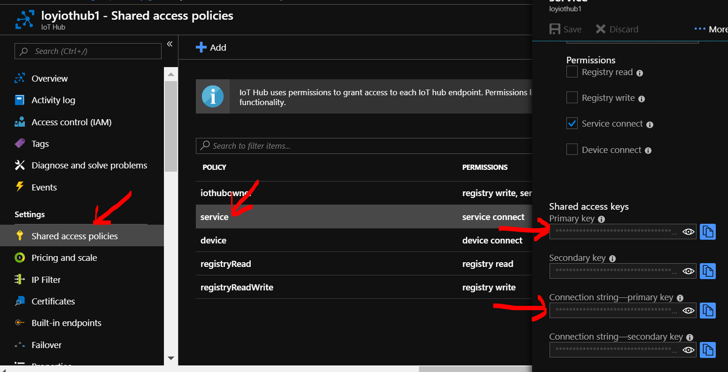

Get device Connection String

Go to IoT Hub

In Explorers click IoT device / Device ID

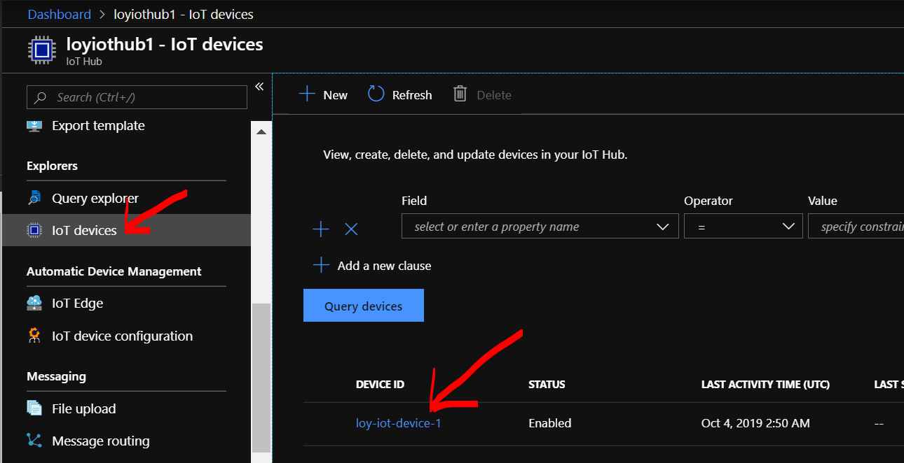

Copy Device ID, Primary Key, Connection String and paste into NotePad

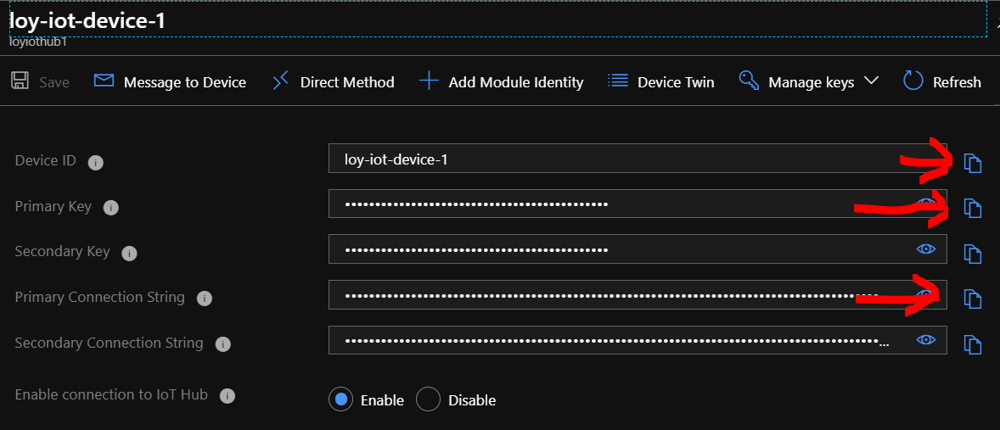

What's next?

